**Radar system Using Ultrasonic sensor**

**Introduction**

The aim of this Arduino Radar project is to achieve a radar system prototype based on an Arduino board that detects stationary and moving objects.

The word RADAR means Radio Detection And Ranging. Radar is an object detection system that uses microwaves to determine the range, altitude, direction, and speed of objects within about a 100-mile radius of their location.

The radar antenna transmits radio waves or microwaves that bounce off any object in their path. Due to this, we can easily determine the object in the radar range

An [**ultrasonic sensor**](https://robu.in/product/hc-sr04-ultrasonic-range-finder/)is a proximity sensor that is used to measure the distance of a target or object. It detects the object by transmitting ultrasonic waves and converts the reflected waves into an electrical signal. These sound waves travel faster than the speed of the sound that humans can hear.

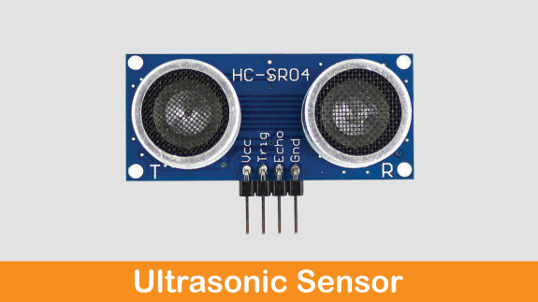**Components**

1. Arduino Uno
2. Breadboard
3. Ultrasonic sensor
4. Servo motor

**Application**

 controlling air traffic, observation of weather, navigation of ship, environment, sensing from remote areas, observation of planetary, measurement of speed in industrial applications, space surveillance, law enforcement, etc.

**Objective**

During this activity ,you will help students to achieve following objectives

1. Understanding the principle and operation of ultrasonic sensor

2. Design algorithm and flowchart to detect obstacle and get alerted

3. Programming ultrasonic sensor using Arduino uno

4. Interfacing ultrasonic sensor with Arduino uno

**Algorithm**

1. Defines Trigger and Echo pins of the Ultrasonic Sensor
2. Define Variables for the duration and the distance
3. Sets the trigPin as an Output and Sets the echoPin as an Input pin
4. Defines on which pin is the servo motor attached
5. Define function for calculating the distance measured by the Ultrasonic sensor for each degree
6. Reads the echoPin, returns the sound wave travel time in microseconds.
7. Check echo pin status value.
8. Rotate motor according input data received.

**Flowchart**

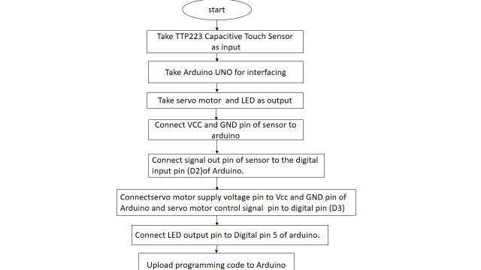

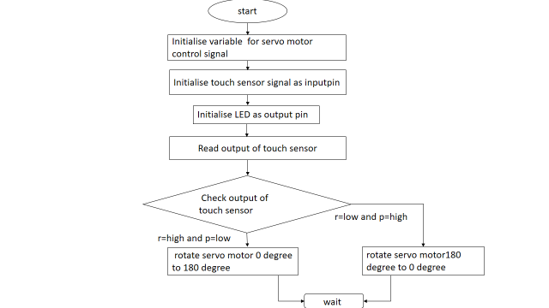

**Programming**

// Includes the Servo library

#include <Servo.h>.

// Defines Tirg and Echo pins of the Ultrasonic Sensor

const int trigPin = 10;

const int echoPin = 11;

// Variables for the duration and the distance

long duration;

int distance;

Servo myServo; // Creates a servo object for controlling the servo motor

void setup() {

  pinMode(trigPin, OUTPUT); // Sets the trigPin as an Output

  pinMode(echoPin, INPUT); // Sets the echoPin as an Input

  Serial.begin(9600);

  myServo.attach(12); // Defines on which pin is the servo motor attached

}

void loop() {

  // rotates the servo motor from 15 to 165 degrees

  for(int i=15;i<=165;i++){

  myServo.write(i);

  delay(30);

  distance = calculateDistance();// Calls a function for calculating the distance measured by the Ultrasonic sensor for each degree

  Serial.print(i); // Sends the current degree into the Serial Port

  Serial.print(","); // Sends addition character right next to the previous value needed later in the Processing IDE for indexing

  Serial.print(distance); // Sends the distance value into the Serial Port

  Serial.print("."); // Sends addition character right next to the previous value needed later in the Processing IDE for indexing

  }

  // Repeats the previous lines from 165 to 15 degrees

  for(int i=165;i>15;i--){

  myServo.write(i);

  delay(30);

  distance = calculateDistance();

  Serial.print(i);

  Serial.print(",");

  Serial.print(distance);

  Serial.print(".");

  }

}

// Function for calculating the distance measured by the Ultrasonic sensor

int calculateDistance(){

  digitalWrite(trigPin, LOW);

  delayMicroseconds(2);

  // Sets the trigPin on HIGH state for 10 micro seconds

  digitalWrite(trigPin, HIGH);

  delayMicroseconds(10);

  digitalWrite(trigPin, LOW);

  duration = pulseIn(echoPin, HIGH); // Reads the echoPin, returns the sound wave travel time in microseconds

  distance= duration*0.034/2;

  return distance;

}

* **Processing  Code:**

import processing.serial.*; // imports library for serial communication

import java.awt.event.KeyEvent; // imports library for reading the data from the serial port

import java.io.IOException;

Serial myPort; // defines Object Serial

// defubes variables

String angle="";

String distance="";

String data="";

String noObject;

float pixsDistance;

int iAngle, iDistance;

int index1=0;

int index2=0;

PFont orcFont;

void setup() {

 size (1200, 700); // ***CHANGE THIS TO YOUR SCREEN RESOLUTION***

 smooth();

 myPort = new Serial(this,"COM8", 9600); // starts the serial communication

 myPort.bufferUntil('.'); // reads the data from the serial port up to the character '.'. So actually it reads this: angle,distance.

}

void draw() {

  fill(98,245,31);

  // simulating motion blur and slow fade of the moving line

  noStroke();

  fill(0,4);

  rect(0, 0, width, height-height*0.065);

  fill(98,245,31); // green color

  // calls the functions for drawing the radar

  drawRadar();

  drawLine();

  drawObject();

  drawText();

}

void serialEvent (Serial myPort) { // starts reading data from the Serial Port

  // reads the data from the Serial Port up to the character '.' and puts it into the String variable "data".

  data = myPort.readStringUntil('.');

  data = data.substring(0,data.length()-1);

  index1 = data.indexOf(","); // find the character ',' and puts it into the variable "index1"

  angle= data.substring(0, index1); // read the data from position "0" to position of the variable index1 or thats the value of the angle the Arduino Board sent into the Serial Port

  distance= data.substring(index1+1, data.length()); // read the data from position "index1" to the end of the data pr thats the value of the distance

  // converts the String variables into Integer

  iAngle = int(angle);

  iDistance = int(distance);

}

void drawRadar() {

  pushMatrix();

  translate(width/2,height-height*0.074); // moves the starting coordinats to new location

  noFill();

  strokeWeight(2);

  stroke(98,245,31);

  // draws the arc lines

  arc(0,0,(width-width*0.0625),(width-width*0.0625),PI,TWO_PI);

  arc(0,0,(width-width*0.27),(width-width*0.27),PI,TWO_PI);

  arc(0,0,(width-width*0.479),(width-width*0.479),PI,TWO_PI);

  arc(0,0,(width-width*0.687),(width-width*0.687),PI,TWO_PI);

  // draws the angle lines

  line(-width/2,0,width/2,0);

  line(0,0,(-width/2)*cos(radians(30)),(-width/2)*sin(radians(30)));

  line(0,0,(-width/2)*cos(radians(60)),(-width/2)*sin(radians(60)));

  line(0,0,(-width/2)*cos(radians(90)),(-width/2)*sin(radians(90)));

  line(0,0,(-width/2)*cos(radians(120)),(-width/2)*sin(radians(120)));

  line(0,0,(-width/2)*cos(radians(150)),(-width/2)*sin(radians(150)));

  line((-width/2)*cos(radians(30)),0,width/2,0);

  popMatrix();

}

void drawObject() {

  pushMatrix();

  translate(width/2,height-height*0.074); // moves the starting coordinats to new location

  strokeWeight(9);

  stroke(255,10,10); // red color

  pixsDistance = iDistance*((height-height*0.1666)*0.025); // covers the distance from the sensor from cm to pixels

  // limiting the range to 40 cms

  if(iDistance<40){

    // draws the object according to the angle and the distance

  line(pixsDistance*cos(radians(iAngle)),-pixsDistance*sin(radians(iAngle)),(width-width*0.505)*cos(radians(iAngle)),-(width-width*0.505)*sin(radians(iAngle)));

  }

  popMatrix();

}

void drawLine() {

  pushMatrix();

  strokeWeight(9);

  stroke(30,250,60);

  translate(width/2,height-height*0.074); // moves the starting coordinats to new location

  line(0,0,(height-height*0.12)*cos(radians(iAngle)),-(height-height*0.12)*sin(radians(iAngle))); // draws the line according to the angle

  popMatrix();

}

void drawText() { // draws the texts on the screen

  pushMatrix();

  if(iDistance>40) {

  noObject = "Out of Range";

  }

  else {

  noObject = "In Range";

  }

  fill(0,0,0);

  noStroke();

  rect(0, height-height*0.0648, width, height);

  fill(98,245,31);

  textSize(25);

  text("10cm",width-width*0.3854,height-height*0.0833);

  text("20cm",width-width*0.281,height-height*0.0833);

  text("30cm",width-width*0.177,height-height*0.0833);

  text("40cm",width-width*0.0729,height-height*0.0833);

  textSize(40);

  text("Indian Lifehacker ", width-width*0.875, height-height*0.0277);

  text("Angle: " + iAngle +" °", width-width*0.48, height-height*0.0277);

  text("Distance: ", width-width*0.26, height-height*0.0277);

  if(iDistance<40) {

  text("        " + iDistance +" cm", width-width*0.225, height-height*0.0277);

  }

  textSize(25);

  fill(98,245,60);

  translate((width-width*0.4994)+width/2*cos(radians(30)),(height-height*0.0907)-width/2*sin(radians(30)));

  rotate(-radians(-60));

  text("30°",0,0);

  resetMatrix();

  translate((width-width*0.503)+width/2*cos(radians(60)),(height-height*0.0888)-width/2*sin(radians(60)));

  rotate(-radians(-30));

  text("60°",0,0);

  resetMatrix();

  translate((width-width*0.507)+width/2*cos(radians(90)),(height-height*0.0833)-width/2*sin(radians(90)));

  rotate(radians(0));

  text("90°",0,0);

  resetMatrix();

  translate(width-width*0.513+width/2*cos(radians(120)),(height-height*0.07129)-width/2*sin(radians(120)));

  rotate(radians(-30));

  text("120°",0,0);

  resetMatrix();

  translate((width-width*0.5104)+width/2*cos(radians(150)),(height-height*0.0574)-width/2*sin(radians(150)));

  rotate(radians(-60));

  text("150°",0,0);

  popMatrix();

}

Hardware

|  |  |  |
| --- | --- | --- |
| Arduino Uno | Ultrasonic Sensor | Servo Motor |
| Vcc | Vcc | Vcc |
| Gnd | Gnd | Gnd |
| D10 | Trig | - |
| D11 | Echo | - |
| D12 | - | Signal |

